

Design Documentation – car dealership

Web and Database Technologies



Contents

Site Map 2

Home Page (WireFrame) 3

Test Drive Page (Wireframe) 4

FAQ’s Page (Wireframe) 5

Cars Page (Wireframe) 6

About Us Page (Wireframe) 7

Sketches 7

General Page Layout 8

Home Page Layout 8

Notable Changes 9

Issues 9

Shrinking the social media logos 9

# Site Map

**Home**

**Contact Us**

**Google Maps**

**Database**

**Booking Form**

**Cars**

**About Us**

**FAQ’s**

**Test Drive**

# Home Page (WireFrame)

Stoke Cars x

**Certification**

**Certification**

Information about getting credit for your car

**Credit Guarantee**

**Image**

Text about the company

**Why Choose Stoke Cars**

**Contact Us**

**Email:** stokecars@mail.com

**Phone Number:** 07436827387

**Test Drive**

**FAQ’s**

**Cars**

**About Us**

**Home**

**Stoke Cars**

**Home Page**

**LOGO**

http://www.stokecars.com

# Test Drive Page (Wireframe)

Test Drive form

**Fill in the form or call/email us to book a test drive**

**Certification**

**Certification**

**Contact Us**

**Email:** stokecars@mail.com

**Phone Number:** 07436827387

**About Us**

**Cars**

**FAQ’s**

**Test Drive**

**Home**

**LOGO**

**Stoke Cars**

**Test Drives**

http://www.stokecars.com

Stoke Cars x

# FAQ’s Page (Wireframe)

Stoke Cars x

**Frequently Asked Questions**

Guide on how to ask questions not covered in FAQ

Questions and Answers

**Ask Your Own Questions**

**Certification**

**Certification**

**Phone Number:** 07436827387

**Email:** stokecars@mail.com

**Contact Us**

**About Us**

**Cars**

**FAQ’s**

**Test Drive**

**Home**

**LOGO**

**Stoke Cars**

**FAQ’s**

http://www.stokecars.com

# Cars Page (Wireframe)

Stoke Cars x

**Certification**

**Certification**

**Contact Us**

**Email:** stokecars@mail.com

**Phone Number:** 07436827387

**Image of Car**

Car Details

**Image of Car**

Car Details

Car Details

**Image of Car**

**About Us**

**Cars**

**FAQ’s**

**Test Drive**

**Home**

**LOGO**

**Stoke Cars**

**Cars**

http://www.stokecars.com

# About Us Page (Wireframe)

Stoke Cars x

# Sketches

**Map**

Text about the company

Address

**Certification**

**Certification**

**Phone Number:** 07436827387

**Email:** stokecars@mail.com

**Contact Us**

**How to Find Us**

**About Us**

**Cars**

**FAQ’s**

**Test Drive**

**Home**

**LOGO**

**Stoke Cars**

**About Us**

http://www.stokecars.com

## General Page Layout

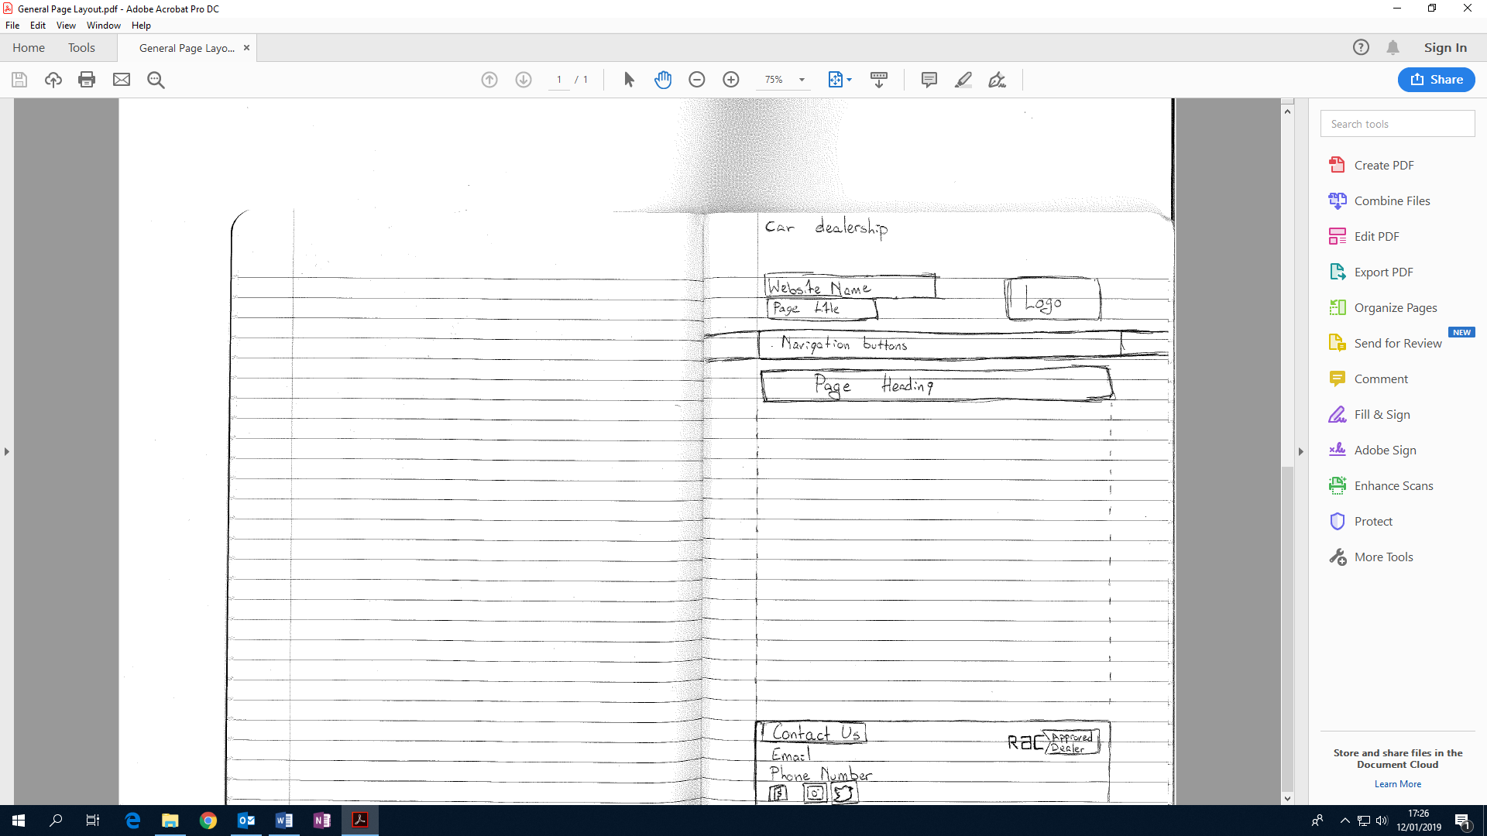

## Home Page Layout

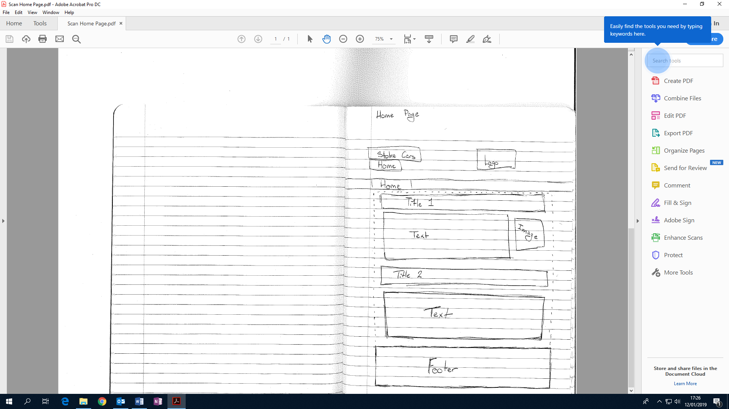

# Notable Changes

Changed the size of the “Car Key Man” image from 3464 x 2309 to 439 x 295. To use less memory space. Although I am using a smaller size on the actual website (333x224) so that it would stay clear even if someone decided to zoom in on the website.



## Issues

### Shrinking the social media logos

Due to the social media logos being transparent, I could not use paint to shrink the image because it would add a white background. To overcome this, I had to go to the library to use the university’s photoshop.



Original Facebook image vs the new size